Exploratory Data Analysis: Part A
Lisa Frazier
Professor John McManamon
DeVry University
August 10, 2023

Contents
Introduction…………………………………………………………………………………………………………………………………………………...…...2
Descriptive Analysis: Sales…………………………………………………………………………………………………………..…………….……...…3
  - Sales Graph …………………………………………………………………………………………………………….......……3
  - Sales Table……………………………………………………………………………………………….…………………….....3
Call Duration Analysis……………………………………………………………………………………………….………………………………………….4
  - Calls Graph………………………………………………….………..…………………………………………………….....….4
  - Calls Table…………………………………………………………………………………………………………………………..4
Years of Experience Analysis………………………………………………………………………………………………………....…………………….5
  - Years Graph ………………………………………………………………………………………………………………..……..5
  - Tears Table…………………………………………………………………………………………………..……………..…..…6
Comparison of Sales and Calls……………………………………………………………………………………………………………………..……….7
  - Comparison Sales and Calls Graph ………………………………………………………………………….………….7
  - Comparison Sales and Calls Table………………………………………………….……………………………….....8
Comparison of Times and Calls……………………………………………………………………………………………………….……………….….13
  - Comparison Times and Call Graph……………………………………………………………………………..…….14
  - Comparison of Times and Calls Table…………………………………………………………..………………..…14
Comparison of Time and Years…………………………………………………………………………………………………….………….……….…15
  - Comparison Time and Years Graph………………………………………………………………………………...16
  - Comparison of Times and Years Table………………………………………………………………………….…16
Conclusion……………………………………………………………………………………………………………………………………………………..….17
Reference…………………………………………………………………………………………………………………………………..…………………..…19

Introduction
Understanding the true trend of business activity requires a thorough understanding of market data analysis and developing the analysis that involves a thorough and focus understanding of the key variable measures. For the Market USA, I looked at a variety of variables in this scenario to gain the whole picture, which is:
- SALES (the total amount of sales in a certain week)
- CALLS (this is the number of calls made per week)
- YEARS (years of call center experience)
- TIME (the typical duration of each call this week)
- TYPE (the training the worker underwent)
- Comparison Sales and Calls
- Comparison Time and Calls
- Comparison
According to the chart analysis, the Market USA averaged 58 sales out of 100 calls. The data's dispersion was determined from 100 sales samples, with the highest reaching 58 and the lowest being 34. The sales data showed a lack of skewness, with a value close to 6, indicating a skewed distribution toward the right side of the mean, median, and mode. The mean sales were 44.87, and the median was 45, further supporting the observation that sales between 42 and 48 occurred with a maximum of 58 sales.

Descriptive Analysis: Sales
Big data holds the promise to provide firms with competitive business intelligence to enhance their strategic decision-making processes (Lau et al. 2016, McAfee and Brynjolfsson 2012). Therefore, an initial analysis was produced to increase sales by way of a “Quantitative Variable” computation to increase sales. According to an analysis, a solid plan for an increase in revenue and productive work hours is needed. This analysis is a descriptive summary of various numerical variables specifically to focus on “Sales." The following sections detail the findings based on table and graphical analysis, comparing the results with the non-numerical variable. (Figure 1).
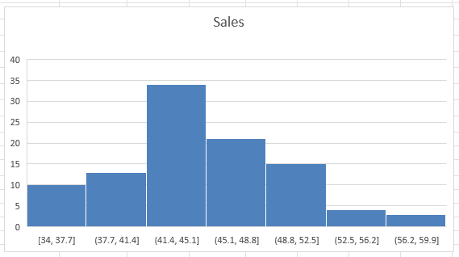Figure: 1 Sales Histogram Graph
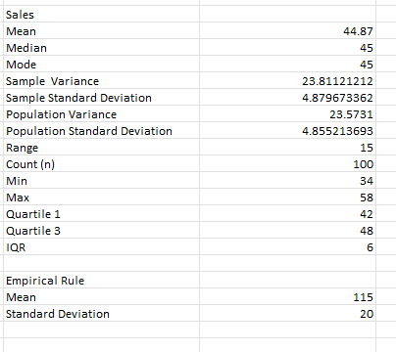Figure: 1.1 Sales Chart Table

Descriptive Analysis Calls:
The sample's average call duration is 147 minutes. When combined with the minor variation in the median of 162, this average reveals a very slight skewness to the right. The sample also revealed information about the sample's number of sales calls. The Market USA made 197 calls on average. The range of sales calls was 148, with 173 being the highest and median at 117 being the lowest. Thereby having an estimation of The Market USA staff members talk on the phone for a maximum of 197 minutes and a minimum of 117. The typical mode is 148 minutes, leaving an IQR of 25 based on the calls format below. The average call duration for the sample was 158.4 minutes, with a minor variation in the median (157.5). This average indicated a slight right skewness in the data. The analysis also revealed that Market USA staff made an average of 143.6 sales calls per day, with a range of 41 calls. The highest number of calls made was 158, and the lowest was 117. The typical mode for call duration was 148 minutes (Figure 2).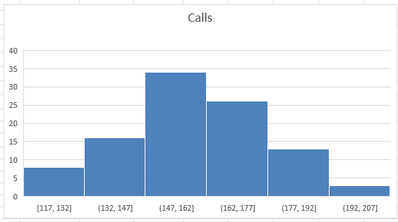 Figure: 1.2 Calls Histogram Graph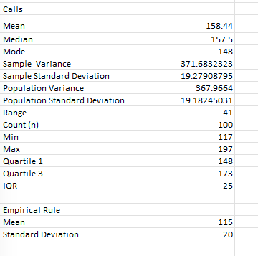Figure: 2.1 Calls Table
Descriptive Analysis Years of Training:
The average length of training for the sample employees was estimated to be around five years. The data's dispersion was calculated from 2 years, with the maximum years being 5. The analysis showed that years of experience data distribution was quantitative variable sampled at regular intervals, as indicated by the near-zero skewness value in the Histogram and numerical summary. The graph below illustrates that, on average, the employees in training had around 1.94 years of calls during their training. Below is a sample analysis of years of calls. Overall Insights: Table
Figure 3:
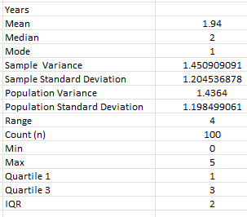 Figure 1.3

Descriptive Analysis Time:
The central tendency of time in this database statistics that the time it tke for the process to occur is equla to 15.25 minutes with mean average of adding up the values in this dataset and dividing it by the number of vsalues. Meanwhile, the median in the middle value is confirme rranged in accendinf and decending order. However, in this case the median is the middle value at 15.2 and the most frequency value modde at 13.6 appears more frequenlly representing this data is most likely to be somewhat od a skewed lower value, as folows in figure 4
Figure 1.3
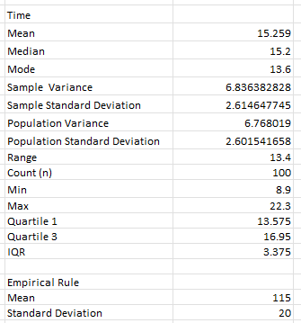Figure 1.4

Comparison of Sales and Calls
Sales scholars have theorized and empirically assessed the associations of myriad predictor variables and salesperson outcomes, such as customer orientation and performance and adaptive selling and job satisfaction (Franke and Park 2006). Based on the scatter plot below, we found that the times of calls were the analysis of the marketing data offered a variety of perspectives and insights that required interpretation. While it emphasized the sales variable and its performance during the week, it also provided valuable information about call duration and the number of sales calls made each day. One limitation is that the analysis was conducted on a limited dataset of 100 groups. Despite this, the research provided helpful insights into how the market operates, supported by various data and graph analysis contexts. However, it is essential to note that the findings did not extensively cover employee call time, which could be a potential area for further investigation. According to the chart below, there is an increase in sales and calls. A primary goal of sales research is to understand how different variables interrelate as predicted by theory. Our objective of qualitative inquiry was to develop an understanding of the activities through which sales teams allocate their time effectively. Sales scholars have theorized and empirically evaluated the associations of myriad predictor variables and salesperson outcomes, such as customer orientation and performance and adaptive selling and job satisfaction (Franke and Park 2006). Therefore, we have noted how much time is spent on each call, in hopes of allocating time management to increase call volume for an increase in salles. Our plot graph shown in figure 5, states that more calls were made during the morning than in the midafternoon. In addition, the graph shows an increase in calls ranging from 8.9 to 22, with an approximate mean of 158 minutes per call, and an increase in time spent with customers where increasing sales.

Figure 5

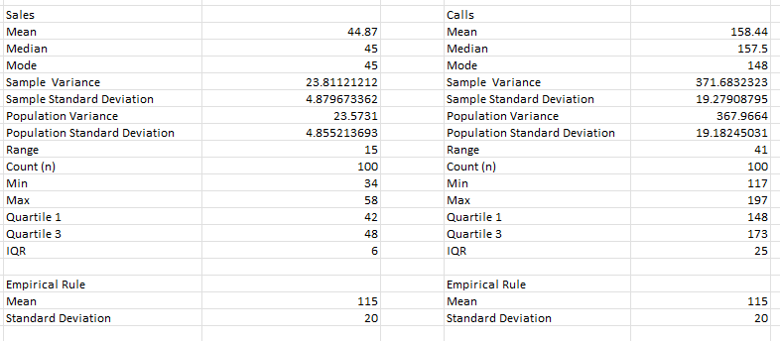
Figure 1.5: Comparison of Sales and Calls:

Comparison of Time vs. Calls:
The analysis of Time vs. Calls, marketing data offered a variety of perspectives and insights that required interpretation. While it emphasized the time (15 minutes) spent on calls and its performance during the week, it also provided valuable information about call duration of 158 minutes verses, the number of calls made each day. One limitation is that the analysis was conducted on a limited dataset of 100 groups. Despite this, the research provided helpful insights into how the market operates, supported by various data and graph analysis contexts. However, it is essential to note that the findings did not extensively cover employee call time, which could be a potential area for further investigation. Over a 2-year period, time spent on calls has increased. I have determined that there is no clear trend as the time passes by and the agents are not taking more calls. Therefore, there appears to be a negative association. In addition, the standard deviation of 2.6 more variation. (Figure shown 1.6)

Figure 6
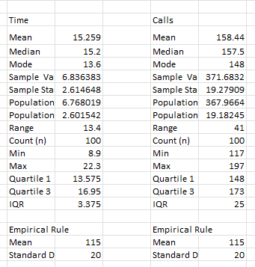
Figure 1.6
Comparison of Time Vs. Years:
My analysis for the approximation of time vs. years states as this: Between 1 and 2 years are the most calls. There may be various types of calls taken to influence time spent on the calls over the years of training accepting each call. The analysis of the marketing data offered minimal perspectives and insights that required interpretation. While it emphasized the time (15 minutes)
Furthermore, analyzing employees' years of experience provided an understanding of the workforce's collective expertise. The data indicated a balanced experience distribution, with an average of around five years and a group process duration of approximately 1.94 years. This suggested a well-established and stable workforce contributing to Market USA's success.

Figure 7
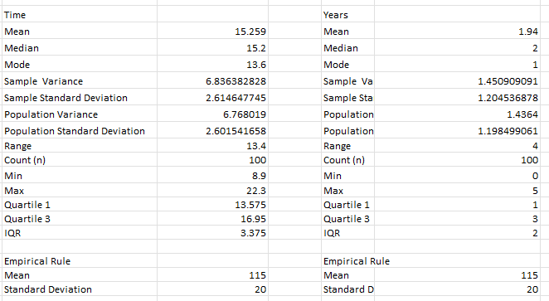
Figure 1.7

Conclusion:
The thorough analysis conducted on the market data, focusing primarily on the "Sales" variable, this subject has provided valuable insights into the performance of Market USA. The study revealed that the average sales out of 100 calls were 58, indicating a commendable conversion rate. The symmetric distribution of sales data around the mean, median, and mode suggested consistent performance across the observed period.
Additionally, examining call duration shed light on the average length of calls and their slight right skewness, indicating the need for efficient and productive conversations with potential customers. The number of daily sales calls, averaging 143.6, showed the company's initiative-taking approach to generating leads. This study focused primarily on the "Sales" variable, leaving room for further investigation into other essential aspects of the business, such as employee call time and its potential impact on sales performance. A more in-depth analysis of call time patterns and strategies could offer practical recommendations for improving sales efficiency.
Furthermore, analyzing employees' years of experience provided an understanding of the workforce's collective expertise. The data indicated a balanced experience distribution, with an average of around five years and a group process duration of approximately 1.94 years. This suggested a well-established and stable workforce contributing to Market USA's success.
Despite the valuable insights and limitations with the excel spreadsheet, I have learned tremendously from this assignment. I was extremely amazed at how the statistical analysis provided a clear, understandable output of the calls, sales, time, and years it took to produce the probability sampling method where researchers can select variance of the population and a regular interval to come to a definite approximation answer. The analysis was conducted on a limited data set of 100 groups, which might only represent part of the market scenario. Therefore, future research could benefit from a more extensive and diverse sample to obtain a comprehensive understanding.
Additionally, the study focused primarily on the "Sales" variable, leaving room for further investigation into other essential aspects of the business, such as employee call time and its potential impact on sales performance. A more in-depth analysis of call time patterns and strategies could offer practical recommendations for improving sales efficiency. this research has enriched my understanding of Market USA's performance and provided valuable insights into the market's dynamics. By leveraging table and graphical analysis, I have gained a comprehensive view of the sales variable's behavior and its relationship with other key factors. As Market USA thrives in the dynamic business landscape, this analysis can serve as a foundation for making informed decisions and implementing strategies to enhance sales and overall business success.

Reference
Johnson, J. S. (2014). Nonlinear analyses in sales research: Theoretical bases and analytical considerations for polynomial models. The Journal of Personal Selling & Sales Management, 34(4), 302-317. https://doi.org/10.1080/08853134.2014.903804
Bahng, Y., & Kincade, D. H. (2012). The relationship between temperature and sales: Sales data analysis of a retailer of branded women's business wear. International Journal of Retail & Distribution Management, 40(6), 410-426. https://doi.org/10.1108/09590551211230232 Professor John McManamon file Excel Spreadsheet templet

Hypothesis Testing and Confidence Intervals: Part B
Lisa Frazier
Professor John McManamon
DeVry University
August 6, 2023

Contents
Introduction………………………………………………………………………………………………………………………………..…..…18
Hypothesis (Ha = 0.05) …………………………………………………………………………………………………………………..….18
Mean Sale (42.50) ………………………………………………………………………………………………….…………………....….18
Proportion Training (55%) ……………………………………………………………………………………………………..…….….19
Mean Calls: No Training (145) ………………………………………………………………………………………………………….20
Mean Times: Per call (14.7) minutes……………………………………………………………………………………….………..20
Eight Steps of Hypothesis Test……………………………………………………………………………………………………….….20
P-Value or Critical Value…………………………………………………………………………………………………………………….21
Compute Confidence: 99%..................................................................................................................21
Step 1: Null and Alternative……………………………………………………………………………………………………………..22
Step 2: Statistical Test………………………………….…………………………………………………………………………………..23
Step 3: Value Set……………………………………………………………………………………………………………………….……..23
Step 4: Decision Rule………………………………………………………………………………………………………………………..23
Step 5: Sample Data………………………………………………………………………………………………………………..……….24
Step 6: Analysis of Data………………………………………………………………………………………………..…………………24
Step 7: Statistical Conclusion……………………………………………………………………………………………….…………..25
Step 8: Business Decision………………………………………………………………………………………………………………..25
Appendix……………………………………………………………………………………………………………………………….……….26
Introduction To Hypothesis Testing: Part B
Understanding the true trend of business activity requires a thorough understanding of market data analysis and developing the analysis that involves a thorough and focus understanding of the key variable measures. For the Market USA, I reviewed a variety of variables in this scenario to gain the whole picture, which is: the following hypothesis, using a = 0.05 for each as follows: Sample mean, Sample Standard Deviation and Sample size from our sales data. Hypothesis test, interpretation, confidence interval, and interpretation is included with this report.
- Mean SALES: Exceed 42.5 per salesperson.
- Proportion: Receiving online training is less than 55%
- Mean CALLS: Made among those with no training is at least 145.
- Mean TIME: Per call is 14.7 minutes.
Confidence Interval Test:
- Mean sales per week exceed 42.5 per salesperson: Claim; The hypothesis is that the mean sales exceeds or that is greater than 42.5 per salesperson which is normal. It is important to find the SE. The hypothesis has three regions, (greater than, equal than and less than). For the confidence Interval, there is 99%. We have a right tailed test with a critical value of 5% and a mating error of 5%, that means your central would be a 90% which would correspond better to the hypothesis test. I used the t distribution because the population is not known. The lower limit is 44.059783 and the upper limit is 45.680217. This is an obvious fail to reject the hypothesis. The actual confidence level is 44.1, to 45,7. Therefore, I am 90% confident that the true population mean is between this range. Sample mean = 44.87 Sample Standard Deviation = 4.879673
Sample size 100
(SE) Standard Error= sample standard deviation divided by the square root of n= 4.879673, divided by square root of 100. If we do this math, we will find the SE is: 0.4879673. This is a right-tail test. So, we would be interested in the right-tailed critical value, the SE, the test statistic, right-sided p-value. I used t-value that corresponds to our sample mean of 44.87, because the sample standard deviation is known.
Therefore, the t-value is equal to 4.856883 or 4.9. The critical value, -1.660391 and test statistics, 4.856883 are marked in red. The p-value is 0.000000 %. This will have to support, reject the null because the mean is greater than 42.5. Their claim was that the alternative mean was greater than 42.5, which is not rejected. Our statistical data was consistent with the value they are claiming. Therefore, we support their claim.
Hypothesis Test: 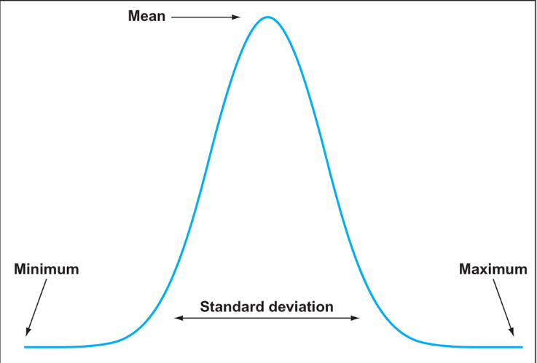

2. The proportion receiving online training is less than 55%: Alpha = 5%. Their statement is that the proportion receiving online training is less than 55%, This is a left-tailed test.

Step 3: Value Set:
Step 4: Decision Rule: left-tail, p value is less than 5%
Step 5: Sample Data: Mean, other stats from week 1, Standard Deviation: This statement is that the mean is greater than.
Step 6: Analysis of Data: Reject the Null and support the claim.
Step 7: Statistical Conclusion: There is enough evidence to support the claim.
Step 8: The Business Decision: The business can be confident that the claim holds.
Confidence Interval: 90%. We are 90% certain that the true portion of people that received online training is lower limit 0.468170 and upper 0.631830. Does not contain the 0.55 population proportion.

- Mean calls made among those with no training; at least 145 calls.
We can look at the calls made for at least is equal to or greater than 145, which is the Null Hypothesis. The Alternative (Ha) would mean the mean is less than 145. The sample size is 18 for those with no training. Mean 151.869565, Sample Standard Deviation is 19.566447, Count 23.
Two-Tail

Step 1: Null and Alternative: The Hypothesis is the Alternative Ha, which is the claim, less than 55%. This is a left-tail test. Since we are dealing with proportion, population claim, we must deal with the sample proportion known as the p-hat. The number of who receive online training is over the total number. I then when to my data sheet. There were 41 online training to be divided by 100 equaling 0.41, n =10
Step 2: Statistical Test: Left-tail test.
Step 3: Value Set:
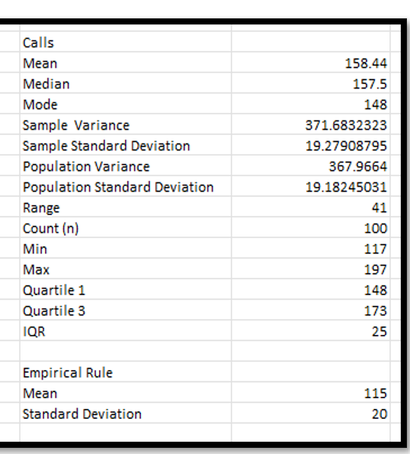
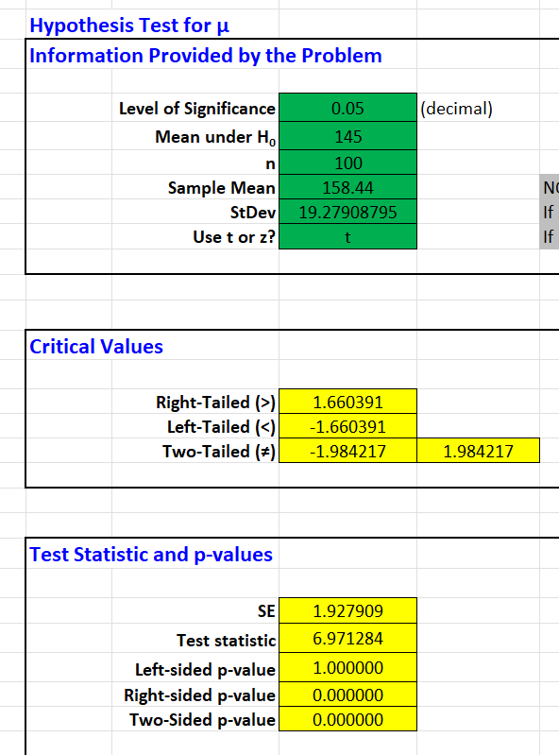
Calls
Step 4: Decision Rule: based on a left-tailed test, the p-value of 1.00000 is greater than 0.05 so we fail-to-reject the null
Step 5: Sample Data: The lower limit is 44.059783 and the upper limit is 45.680217. This is an obvious fail to reject the hypothesis. The actual confidence level is 44.1, to 45,7. Therefore, I am 90% confident that the true population mean is between this range. Sample mean = 44.87 Sample Standard Deviation = 4.879673. Sample size 100.

Step 6: Analysis of Data: Left-tailed test.
Step 7: Statistical Conclusion: We can’t support the claim.
Step 8: The Business Decision: There appears that the number of calls for those getting training is less. than 145 so management might need to adjust how they coach agents.
Mean time per call is 14.7 minutes. This creates a two-tail test. The equal too is part agents.. Null. This time you split 0.05 to 2.5. I used the 90% confidence level. Claim: Null H0: u > 145, Alternative Ha: u < 145.
One-Tail

Using the same data set from Part A, a Hypothesis Test was performed for each speculation to support the manager’s belief. I used the Eight Steps of the Test Hypothesis from section 9.1 of the books: Business Statistics: For contemporary Decision Making.
Step 1:
Null and Alternative:
Understanding the four hypotheses, using a formal structure derived from a scientific of a Null hypothesis which makes use of the old theory and the new the theory which a change has occurred. The alternative hypothesis “complement” of the null hypothesis can be true. The testing I have done will show the outcome of which results produce. Consequently, the training outcome may or may not be a significant outcome for the training and may be unlikely to occur by chance. For example: Left tail is less than, Middle or mean is two tail or equal to and the Right tail is greater than, therefore depending on the measures of variables will the known outcomes be established.
The Null and Alternative hypothesis is that training consists of a value of more than 42.5 sales per week. The alternative hypothesis testing mean is less than or equal to 42.5, the central value. This test is an alpha of 5% and matching critical error of 5%. Meaning the central is at 90% confident level. Upper limit 45.680216 lower limit 44.059784 population standard of deviation is known, I used the t value. The t test measures the difference between observed statistics and hypothesized population parameter of the standard deviation. This is a (right-tail test, claim), Fail to reject the Null. (Page 29 Appendix).
Step 2:
Statistical Test:
The Appropriate Statistical test I used is Hypothesis test for mean, information provided by the problem on week 5 spreadsheet. The statistical test is one sample t-value for the population mean. The significance level: a = 0.05. (Test Statistic t-value). Hence the claim proportion receiving online training is less than 55%. Meaning, an average of the given number dividing the sum of the given numbers by the total number of numbers. (Sum of all observation/Total number of observations). Page 30
Step 3:
Value Set:
The Null Hypothesis is that the population is greater than or equal to 55%.
H0 >/ = 0.55.
The Alternative Hypothesis is that it would be less than 55% Ha < 0.55.
Included equations:
- Claim for mean sales per week exceed 14.5 per salesperson = Ho > 14.5.
- The proportion receiving online training is less than 55% = Ho < 0.55%.
- Mean Calls made among those with no training is at least 145 calls = Ho >/=145.
- Mean Time per Call is 14.7 minutes = Ho = 14.7
Step 4: Decision Rule:
Reject with a left- tailed test. We then specify a significance level, 99% confidence the intervals for the variables used in each hypothesis test, allowing me to estimate the accurate population parameters with a high confidence level and calculate the test statistics. Then I produced a calculated chart of the critical value. I concluded that the chart represents a null (Ho) Hypothesis, 0.05 level of significance, mean under Ho of 14.5. Sample mean,14.7 and a standard deviation of 55%. Using the t for population. The reason for rejection is the right-side shows a significant drop as opposed to the:
left at 0. 000000.The t- test is negative 3.290527, t-value. (Hypothesis Test). The P-value sample proportion of 0.410000, where are alpha value is 0.05 percent. We reject the null. Their claim is supported.
Step 5:
Sample Data: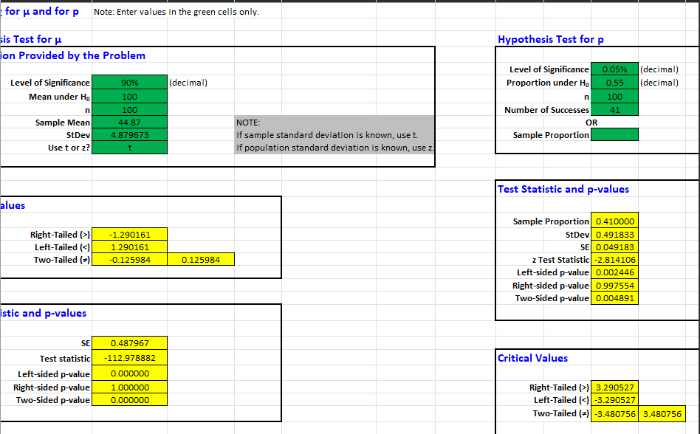
Step 4
Step 6:
Analysis of Data:
The value of equation for the y-hat is the predicted value of the dependent variable regression equation that is positive, which denotes a higher positive correlation between the two variables. The Sales and Calls have a strong positive relationship and therefore the business can maintain the effectiveness of their calls to increase their sales rate. Hence, the coefficient of R squared to test the relationship between the two variables shown below meets their expectations of sales increase.
Y-hat = 0.1388 + 22.197
R2 = 0.219 (29%)
Step 7:
Statistical Conclusion: The Null and Alternative hypothesis is that training consists of a value of more than 42.5 sales per week. The alternative hypothesis testing mean is less than or equal to 42.5, the central value. This test is an alpha of 5% and matching critical error of 5%. Meaning the central is at 90% confident level. Upper limit 45.680216 lower limit 44.059784 population standard of deviation is known, I used the t value. The t test measures the difference between observed statistics and hypothesized population parameter of the standard deviation. This is a (right-tail test, claim), Fail to reject the Null. There was evidence to support the data from the chart in the appendix on page 29.
Step 8:
The Business Decision made was to fail to reject the hypothesis of the test statistics being a two tailed test statistical p-value, I fail to reject the hypothesis which is represented in the data on the chart below in the appendix on page 29.

Appendix:
: 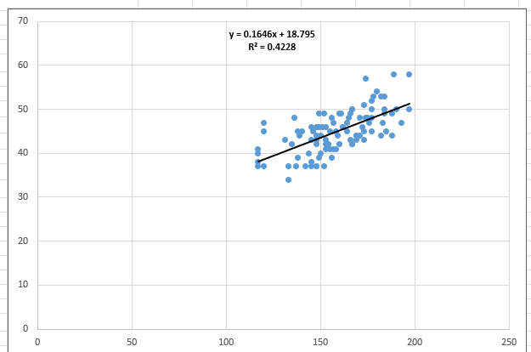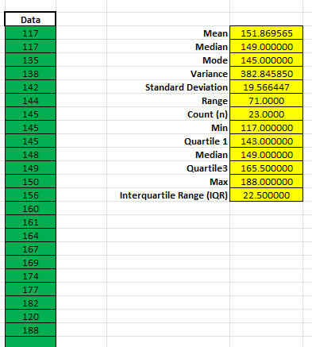

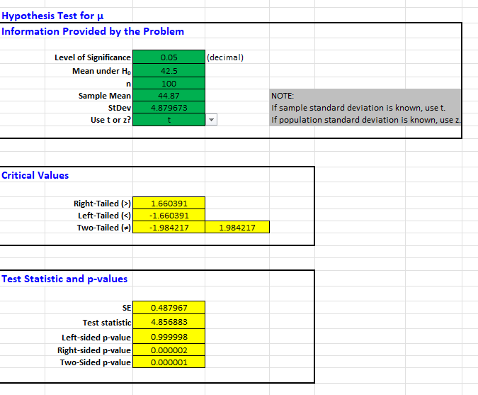
Step 4
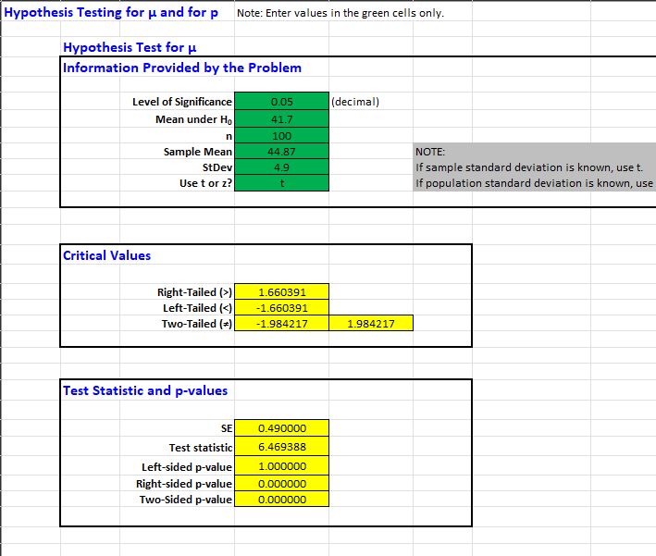

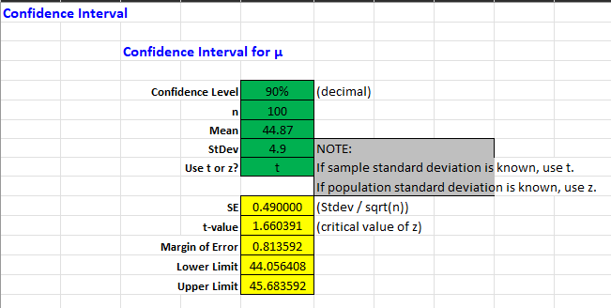
(Step 1)
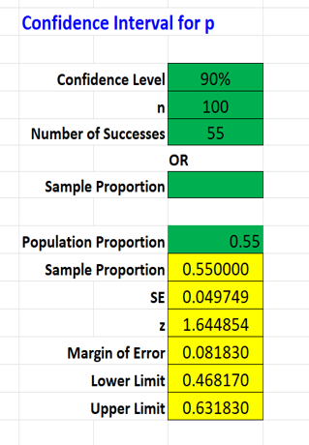

(Step 2)
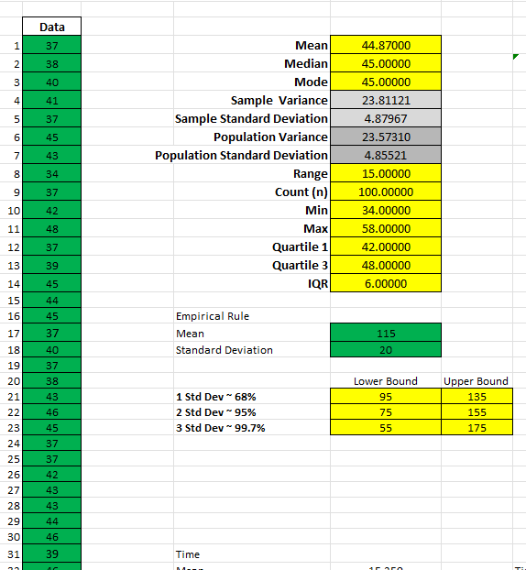

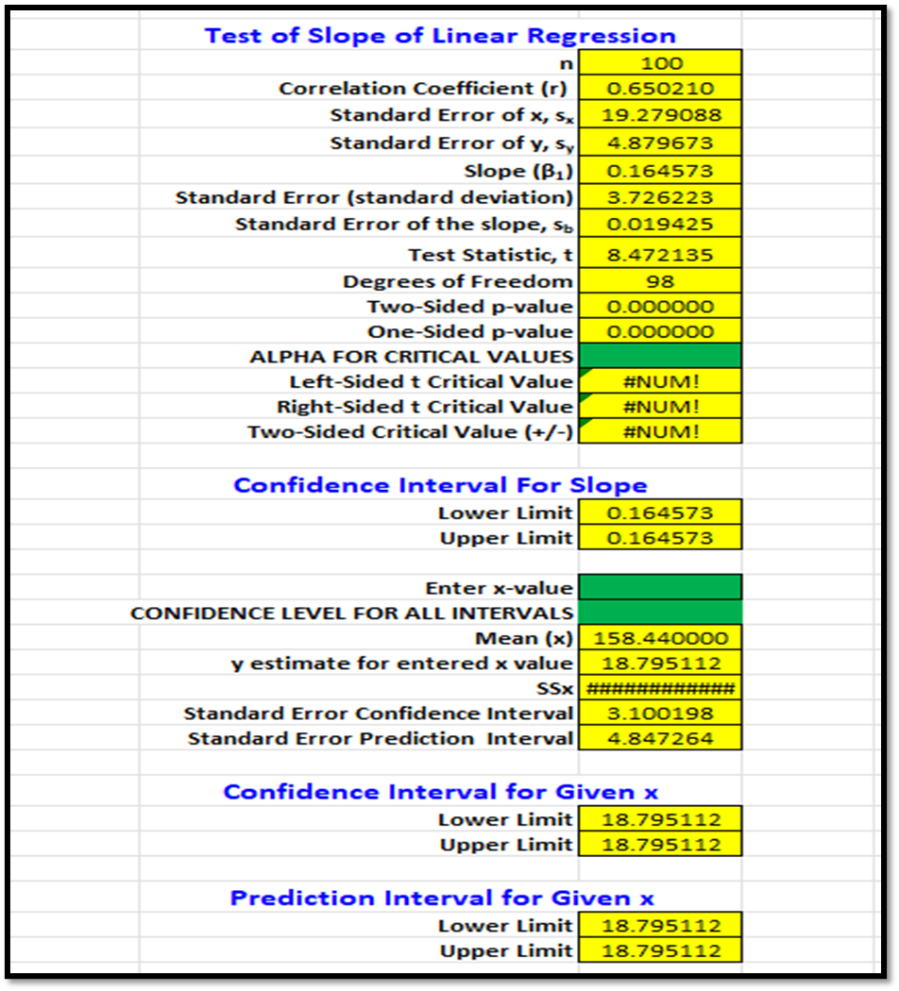

Regression and Correlation Analysis: Final Project
Lisa Frazier
Professor John McManamon
DeVry University
August 18, 2023

Table of Contents
1: Scatterplot……………………………………………………………………………………………38
2: Equation of the “Best Fit” Line……………………………………………………………..38
3: The Correlation Coefficient…………………………………………………….….38
4: Coefficient of Determination………………………………………………………39
5: Test the Utility………………………………………………………………………..39
6: Based on the findings in steps 1-5……………………………………………….39
7: Compute the confidence interval for β………………………………………….39
8: Compute the 99% confidence interval………………………………………..…40
9: Using the same chosen value for part (8) ...…………………………………...40
10: What can be said about the value………………………………………………41
11: Describe a business decision………………………………………………..….41
12: Statistical results…………………………………………………………….……41
13. Appendix…………………………………………………………………….………42

- Generate a scatterplot for the specified dependent variable (Y) and the selected independent variable (X), including the graph of the:
"Best fit" line. Interpret: In our regression model we will have several models which each constant will relate to that distribution. Also, intercept… it can be constant or zero.
Aggregate level…y-hat is called the response variable; the x is called individual variables or explanatory.
Individual variables..x1, x2, x3, x4.
We will create a model: y-hat + β0, β1, β2, β3, β3………..these are slopes.
B1 value which is a central or range of value. Each beta has its own confidence interval.
Hypothesis Testing is the null hypothesis Ho: β1 equal β2 + β3+……+ 0.
If we test for zero and it isn’t we know we have a predictor, if beta was zero it would not contribute anything to our model if it’s something different than zero then we know which variables to consider If it’s not zero this is the alternative, then we got something. (predictor). Confidence Interval formula: β1 plus or minus t-score rimes standard error. The standard error is equal to the standard deviation. Divided by the square root of n. Call would not be rejected H0: β1 = 0.
[--------------value-----------]
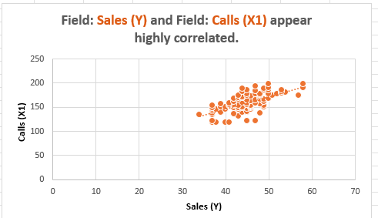

- Determine the equation of the "best fit" line, which describes the relationship between the dependent variable and the selected independent variable:
- (y = mx + β)
- Y = 0.1388) + 22.197
- Determine the correlation coefficient. (Beta) Slop. The y-hat is the Intercept coefficient (SALES): y-hat = 20.462321 + calls 0.15 x1 + -0.19x2 + -0.3 x3
- Coefficient of Correlation = r =29%
- Since the coefficient is 29% we can say this is a weak predictor of our model.
So, Sales = 20.5 + 0.2 (Calls) -0.2 (Time) + 0.3 (Years). Hence, zero call, zero time and zero time will still make 20.5 calls.

- Determine the coefficient of determination: Interpret: Calls, Times, and Years--- Beta1. Beta2 and Beta3 are the coefficients.
- Coefficient of determination = R2 = 0.2919
- Based on the coefficient determination, we can say 29% of the response variable variation is explained by our linear model.
- Test the utility of this regression model by completing a hypothesis test of β=0 using α=0.10. Interpret results, including the p-value.
If x = 100 then y = (.0.1388*100) + 22.197 will equate to 22.336
We would reject the null hypothesis of the P-Value is 0 (P > Alpha = Reject)
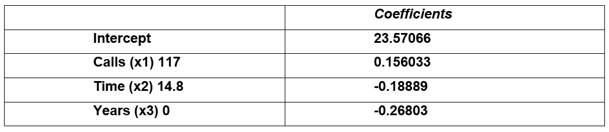

- Based on the findings in steps 1-5, analyze the ability of the independent variable to predict the dependent variable.
- Based on steps 1-5, we can see that there is a positive correlation between the number of calls (x) and the sales (y). We can use this to speculate on the calls an employee makes, the chances of an increase in sales are larger. Hence, we would state, due to the coefficient of correlation at 29%, we have a weak predictor for our model outcome. Usually, it’s best to have a percentage higher than 75 that would indicate a strong correlation. Consequently, these findings are based on how far our data points away from the best fit line.
- Compute the confidence interval for β, using a 95% confidence level. Interpret this interval.
Distribution Plot
- Based on the information given from the regression model in exercise 5, the coefficient value is .14.5 the test statistic is 14.5, and the Standard Error (SE) is equal to .0. The formula to calculate the confidence interval of Beta1 is:
- β1 -t*Seo1 = Lower Confidence = 32.68403.
- β1 – t*Seo1 = Upper Confidence = 14.4573.
- We are 95% confident that the slope fails within this interval.

- Compute the 99% confidence interval for the dependent variable, for a selected value of the independent variable. Each student can choose a value to use for the independent variable (use same value in the next step). Interpret this interval.
- According to the information given from our regression analysis and sales and calls, we can speculate that we are 95% confident that the average number of sales will fall within the above confidence interval.

- Using the same chosen value for part (8), estimate the 99% prediction interval for the dependent variable. Interpret this interval.
- 95% Prediction Interval
- According to the information given from our regression analysis and sales and call, we can speculate that we are 955 confident that the new observation (value) will fall within the above prediction interval. The prediction interval is always wider than the corresponding confidence interval. Hence, the added uncertainty involved in predicting a single response versus the mean response.
- What can be said about the value of the dependent variable for values of the independent variable that are outside the range of the sample values?
- Predication that is outside of the day are not meaningful because of the linear model is fit to a specific data group. For example: A model that shows the relationship between the speeds of semi-trucks will apply the same model values using FICO scores would produce abnormal results, and the relationship between the type of score and type is not the same for all scores.
- Describe a business decision that could be made based on the results of this analysis. In other words, how might the business operations change have based on:
- The regression equation is Sales (Y) = 14.5/145 Calls (X1) – 14.7 Time (X2) – 2 Years (Y3).
- Statistical results
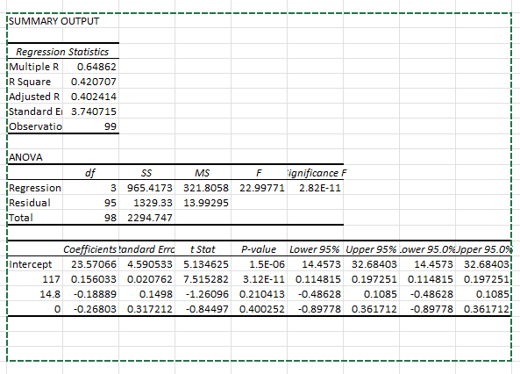

Appendix:
Based on the On-Line calls:
 | Data
1 | 3 | ONLINE
2 | 0 | ONLINE
3 | 1 | ONLINE
4 | 4 | ONLINE
5 | 0 | ONLINE
6 | 1 | ONLINE
7 | 2 | ONLINE
8 | 4 | ONLINE
9 | 3 | ONLINE
10 | 2 | ONLINE
11 | 1 | ONLINE
12 | 2 | ONLINE
13 | 2 | ONLINE
14 | 0 | ONLINE
15 | 5 | ONLINE
16 | 3 | ONLINE
17 | 0 | ONLINE
18 | 3 | ONLINE
19 | 5 | ONLINE
20 | 1 | ONLINE
21 | 0 | ONLINE
22 | 1 | ONLINE
23 | 1 | ONLINE
24 | 2 | ONLINE
25 | 2 | ONLINE
26 | 0 | ONLINE
27 | 1 | ONLINE
28 | 2 | ONLINE
29 | 3 | ONLINE
30 | 1 | ONLINE
31 | 2 | ONLINE
32 | 1 | ONLINE
33 | 2 | ONLINE
34 | 2 | ONLINE
35 | 2 | ONLINE
36 | 0 | ONLINE
37 | 1 | ONLINE
38 | 1 | ONLINE
39 | 1 | ONLINE
40 | 2 | ONLINE
41 | 2 | ONLINE
42 | 1 | ONLINE
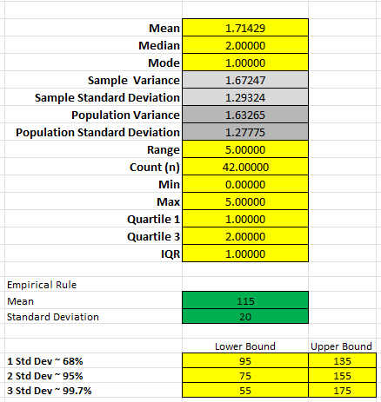

Based on Groups:
 | Data
1 | 0 | GROUP
2 | 2 | GROUP
3 | 2 | GROUP
4 | 1 | GROUP
5 | 4 | GROUP
6 | 1 | GROUP
7 | 2 | GROUP
8 | 2 | GROUP
9 | 4 | GROUP
10 | 2 | GROUP
11 | 1 | GROUP
12 | 3 | GROUP
13 | 3 | GROUP
14 | 1 | GROUP
15 | 3 | GROUP
16 | 1 | GROUP
17 | 1 | GROUP
18 | 2 | GROUP
19 | 1 | GROUP
20 | 1 | GROUP
21 | 0 | GROUP
22 | 1 | GROUP
23 | 2 | GROUP
24 | 3 | GROUP
25 | 3 | GROUP
26 | 2 | GROUP
27 | 1 | GROUP
28 | 3 | GROUP
29 | 1 | GROUP
30 | 3 | GROUP
31 | 2 | GROUP
32 | 2 | GROUP
33 | 2 | GROUP
34 | 4 | GROUP
35 | 3 | GROUP
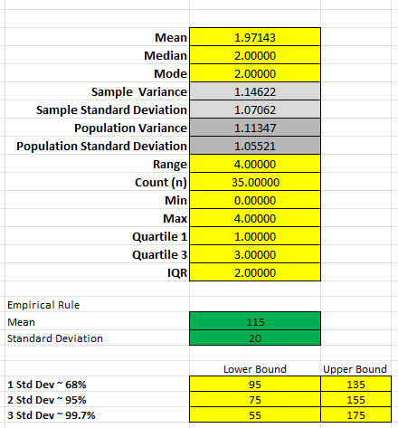

Based on None:

 | Data
1 | 3 | NONE
2 | 1 | NONE
3 | 3 | NONE
4 | 1 | NONE
5 | 2 | NONE
6 | 0 | NONE
7 | 3 | NONE
8 | 2 | NONE
9 | 2 | NONE
10 | 1 | NONE
11 | 3 | NONE
12 | 1 | NONE
13 | 4 | NONE
14 | 3 | NONE
15 | 3 | NONE
16 | 3 | NONE
17 | 2 | NONE
18 | 4 | NONE
19 | 2 | NONE
20 | 4 | NONE
21 | 4 | NONE
22 | 1 | NONE
23 | 1 | NONE
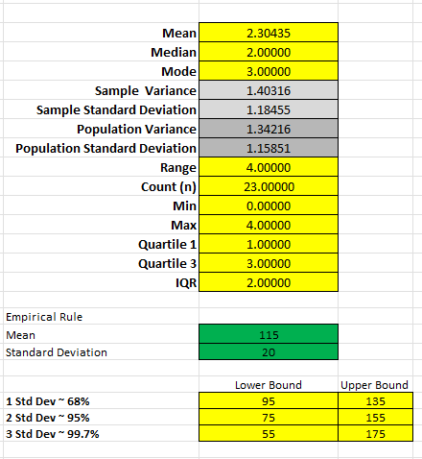

Reference:
https://support.minitab.com/en-us/minitab/21/help-and-how-to/statistics/basic-statistics/supporting-topics/tests-of-means/what-is-a-z-value/#:~:text=The%20Z%2Dvalue%20is%20a,units%20of%20the%20standard%20deviation.
https://byjus.com/maths/mean/#:~:text=Definition%20of%20Mean%20in%20Statistics,observations%2FTotal%20number%20of%20observations)
https://vwo.com/blog/errors-in-ab-testing/

